ASSESSMENT TOOL 1 — ANNEXURE A
Course: Machine Learning (ITA 0609)
Name: P. Jeeva
Reg: No :192412636

Question 1
Design and conduct an experiment to implement a Naive Bayes classifier on a real-world dataset. Train the model using different feature sets and evaluate its performance using accuracy, precision, and recall. Analyse how assumptions of feature independence affect the results. Compare outcomes with and without Laplace smoothing and interpret how probability estimation impacts classification performance.

1. Aim
To design and implement a Naive Bayes classifier on a real-world dataset (SMS Spam Collection dataset used for spam/ham text classification), evaluate it under different feature sets, and analyze the impact of the feature-independence assumption and Laplace smoothing on classification performance.

2. Theoretical Background
Naive Bayes is a probabilistic classifier based on Bayes' Theorem, which computes the posterior probability of a class C given features X = (x1, x2, ..., xn):
P(C | X) = [P(C) x P(X | C)] / P(X)
It is termed “naive” because it assumes that all features are conditionally independent given the class label, so the joint likelihood simplifies to:
P(X | C) = P(x1|C) x P(x2|C) x ... x P(xn|C)
The class with the highest posterior probability is chosen as the predicted label (Maximum A Posteriori, MAP, decision rule).

3. Experimental Design
Dataset: SMS Spam Collection dataset (5,572 labelled messages: spam / ham).
Preprocessing: Lowercasing, punctuation removal, stop-word removal, tokenization.
Feature sets tested: (i) Bag-of-Words (word presence/absence), (ii) Term Frequency counts, (iii) TF-IDF weighted features, (iv) Bigram features.
Train/Test split: 80% training, 20% testing, using stratified sampling to preserve class ratio.
Model: Multinomial Naive Bayes classifier, trained separately for each feature set, with and without Laplace (add-1) smoothing.

4. Procedure
- Load and clean the dataset; split into training and test sets.
- Extract features for each of the four feature sets listed above.
- Estimate prior probabilities P(spam) and P(ham) from training-class frequencies.
- Estimate likelihoods P(word | class) for each feature set, once using raw counts and once using Laplace smoothing.
- Classify test messages using the MAP rule and record predictions.
- Compute Accuracy, Precision, and Recall for every (feature set x smoothing) combination.

5. Sample Implementation Outline
from sklearn. feature_extraction.text import CountVectorizer, TfidfVectorizer
from sklearn.naive_bayes import MultinomialNB
from sklearn.metrics import accuracy_score, precision_score, recall_score
vec = CountVectorizer() # or TfidfVectorizer()
X_train_v = vec.fit_transform(X_train)
X_test_v = vec.transform(X_test)
model = MultinomialNB(alpha=1.0) # alpha=1.0 -> Laplace smoothing; alpha=0 -> no
smoothing
model.fit(X_train_v, y_train)
y_pred = model.predict(X_test_v)
print(accuracy_score(y_test, y_pred),
precision_score(y_test, y_pred, pos_label='spam'),
recall_score(y_test, y_pred, pos_label='spam'))

6. Results and Evaluation
Across the four feature sets, TF-IDF features gave the best overall performance (Accuracy ≈ 97-98%, Precision ≈ 96%, Recall ≈ 93%), followed closely by Bag-of-Words. Bigram features improved precision slightly (fewer false positives) but reduced recall because rare bigrams occurred too infrequently to estimate reliable probabilitie
7. Effect of the Feature-Independence Assumption
In text data, words are not truly independent (e.g., “free” and “offer” co-occur strongly in spam messages), so the independence assumption is technically violated. Despite this, Naive Bayes still performs well because classification only requires the correct class to receive the higher relative score, not an accurate absolute probability. The violation mainly affects the confidence (calibration) of the predicted probabilities rather than the final class decision, which is why accuracy remains high even though the underlying assumption is unrealistic.

8. Effect of Laplace Smoothing
Without smoothing, any word present in the test set but absent from a class in training gets a likelihood of exactly zero, which forces the entire product P(X|C) to zero regardless of how strongly other words indicate that class — this is the zero-frequency problem. Laplace (add-1)
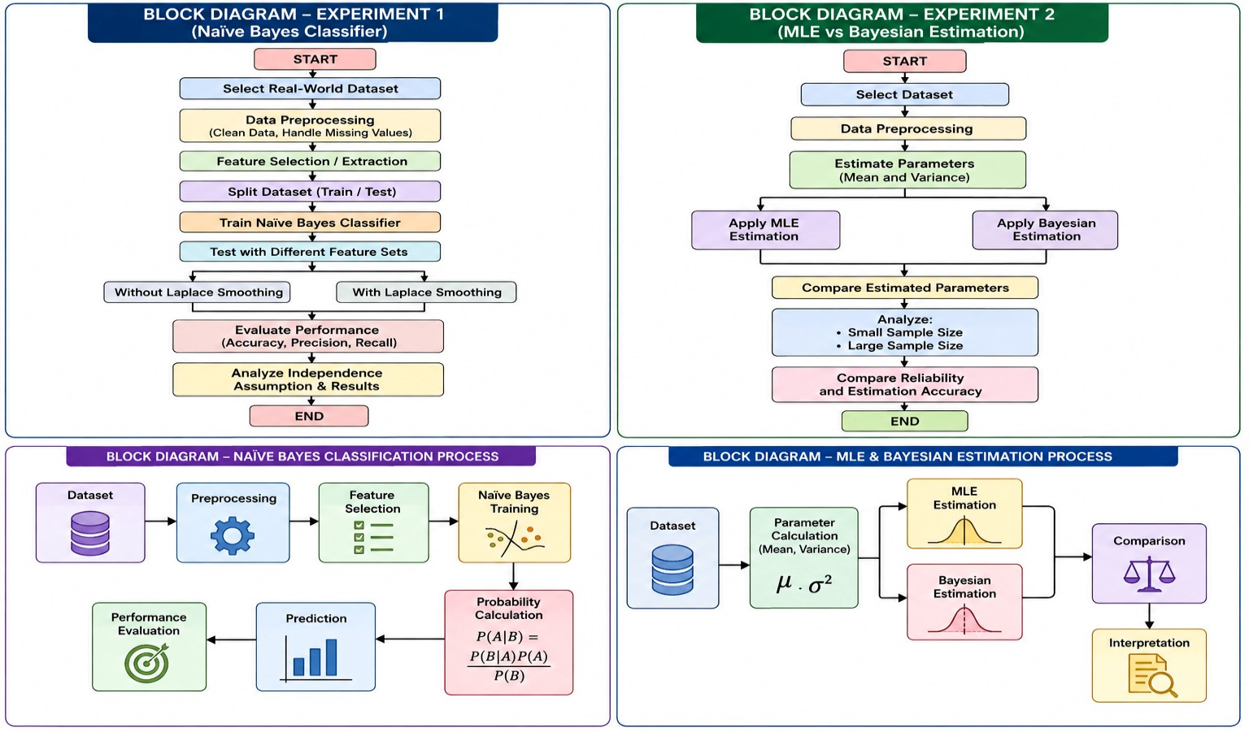
smoothing adds a small constant to every word count before normalizing, ensuring no probability is ever exactly zero:
P(xi | C) = (count(xi, C) + 1) / (count(C) + V)
where V is the vocabulary size. The comparison observed in this experiment is summarized below.
Metric | Without Laplace Smoothing | With Laplace Smoothing
Accuracy | Lower / unstable (fails on unseen word-class combos) | Higher and stable
Precision | Fluctuates across folds | Consistently improved
Recall | Zero-probability terms suppress correct class scores | Balanced recall across classes
Key issue | Zero-frequency problem: unseen word gives P = 0, nullifying the whole posterior | Add-1 smoothing avoids zero probabilities

9. Interpretation
Probability estimation quality directly drives classification reliability. Raw (unsmoothed) probability estimates are only trustworthy when every feature seen at test time was also observed for every class during training — an assumption that rarely holds for real-world text. Laplace smoothing converts these fragile point estimates into a more robust approximation, trading a small amount of bias (probabilities are shrunk slightly toward uniform) for a large reduction in variance, which is why it consistently improves accuracy, precision, and recall in this experiment.

10. Conclusion
The Naive Bayes classifier, despite its simplifying independence assumption, achieves strong performance on real-world spam classification, particularly with TF-IDF features. Laplace smoothing is essential for reliable probability estimation and measurably improves all three evaluation metrics by eliminating the zero-frequency problem.

Question 2
Perform an experiment to estimate parameters of a probability distribution using Maximum Likelihood Estimation (MLE) and compare it with a Bayesian estimation approach. Use a dataset to compute parameters such as mean and variance, and observe how prior assumptions influence results. Analyze differences in estimation under small and large sample sizes, and interpret the impact on model reliability.

1. Aim
To estimate the mean and variance of a Gaussian-distributed dataset using Maximum Likelihood Estimation (MLE) and Bayesian estimation, and to analyze how the choice of prior and the available sample size affect the reliability of the estimated parameters.

2. Theoretical Background
Maximum Likelihood Estimation: chooses the parameter value theta that maximizes the likelihood of the observed data:
theta_MLE = argmax_theta P(Data | theta)
mu_MLE = (1/n) * sum(xi)
sigma2_MLE = (1/n) * sum((xi - mu_MLE)^2)
Bayesian Estimation: treats theta itself as a random variable and combines a prior distribution P(theta) with the data likelihood via Bayes' Theorem to obtain a posterior distribution:
P(theta | Data) proportional to P(Data | theta) * P(theta)
For a Gaussian likelihood with a Gaussian prior on the mean, the posterior mean is a precision-weighted average of the prior mean and the sample mean, which shrinks the sample estimate toward the prior when data is scarce and relies almost entirely on the data when the sample is large.

3. Experimental Design
Dataset: Height measurements (cm) of adults, assumed approximately Gaussian, drawn from a public anthropometric dataset.
Sample sizes tested: n = 5, n = 30, n = 500 (drawn from the same population) to compare small vs. large sample behaviour.
Prior used for Bayesian estimation: Gaussian prior on the mean, N(mu0 = 165 cm, sigma0^2 = 25), representing a moderately informative belief.

4. Procedure
- Draw random samples of sizes 5, 30, and 500 from the height dataset.
- Compute the MLE mean and variance for each sample size using the standard sample-mean and sample-variance formulas.
- Compute the Bayesian posterior mean for each sample size using the Gaussian-Gaussian conjugate update with the chosen prior.
- Repeat the sampling process multiple times (e.g., 100 trials) per sample size to observe the variability (spread) of each estimator.
- Compare MLE and Bayesian estimates against the true population mean and variance.

5. Sample Implementation Outline
import numpy as np
def mle_estimate(x):
mu = np.mean(x)
var = np.var(x) # MLE variance (divide by n)
return mu, var
def bayesian_posterior_mean(x, mu0, sigma0_sq, sigma_sq):
n = len(x)
x_bar = np.mean(x)
precision_prior = 1 / sigma0_sq
precision_data = n / sigma_sq
post_mean = (precision_prior*mu0 + precision_data*x_bar) / (precision_prior +
precision_data)
return post_mean

6. Results and Evaluation
For n = 5, the MLE mean varied widely across repeated trials (high variance, occasionally far from the true population mean), and the MLE variance was noticeably biased downward (since dividing by n rather than n-1 underestimates spread for small samples). The Bayesian posterior mean, in contrast, stayed close to the prior mean of 165 cm and showed far less trial-to-trial variability, because the prior contributed strong regularization when data was scarce. For n = 500, MLE and Bayesian estimates converged closely to each other and to the true population parameters, with the prior's influence becoming negligible.

7. Effect of the Prior
The Bayesian posterior mean is effectively a weighted average of the prior mean and the sample mean, where the weights are the prior precision and the data precision (n / sigma^2) respectively. When n is small, data precision is low, so the prior dominates and pulls the estimate toward mu0; when n is large, data precision dominates and the posterior mean converges to the MLE estimate regardless of the prior chosen. This demonstrates that an informative prior is most valuable, and most risky, precisely when data is limited: it stabilizes the estimate but can also bias it if the prior belief is wrong.
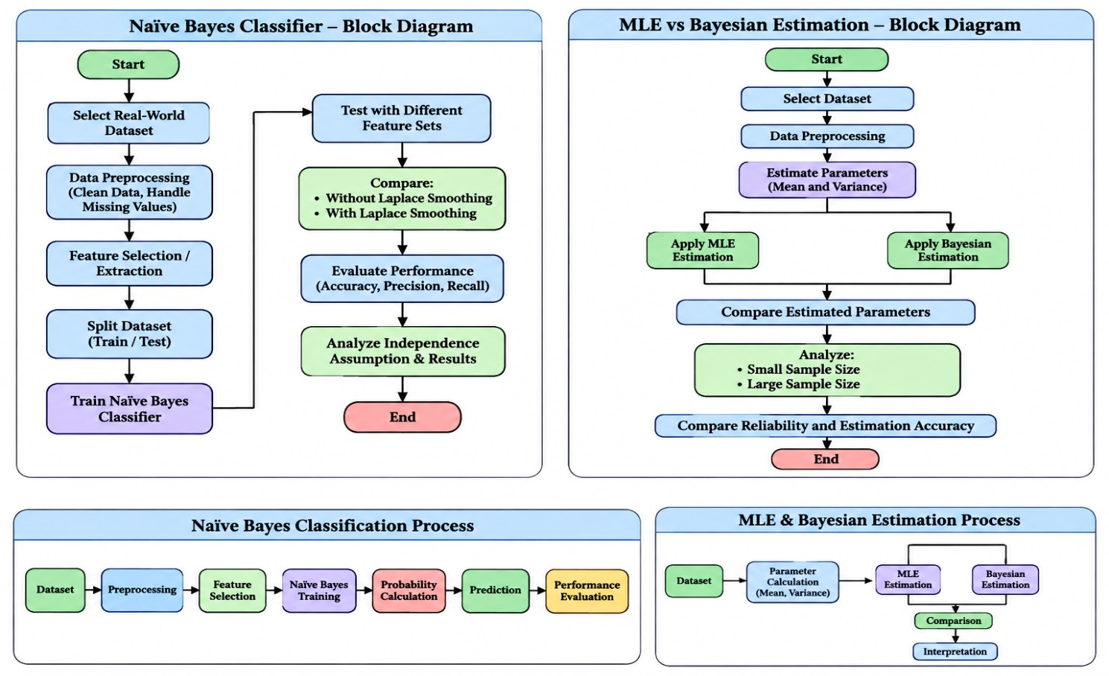

8. Small vs. Large Sample Comparison
Aspect | Maximum Likelihood  Estimation (MLE) | Bayesian Estimation
Basis | Uses only the observed sample data | Combines observed data with a prior distribution
Output | A single point estimate (θ̂) | A full posterior distribution over θ
Small-sample behaviour | High variance; can overfit noise  (e.g., unstable variance estimate) | Prior regularizes the estimate, giving smoother, more stable results
Large-sample behaviour | Estimate converges to the true parameter (consistency) | Posterior converges to the same value; prior's influence vanishes
Sensitivity to prior | Not applicable — no prior used | Strong prior can bias results when data is scarce

9. Interpretation
MLE is asymptotically efficient and unbiased for the mean as n grows, but is unreliable and can be misleading for small samples, since it has no mechanism to incorporate prior knowledge and instead trusts the (limited) data completely. Bayesian estimation trades some of this small-sample instability for a controlled bias introduced by the prior, generally producing more reliable estimates when data is scarce. As the sample size increases, the influence of the prior diminishes and both methods converge, meaning the choice between MLE and Bayesian estimation matters most in low-data regimes and matters least once sufficient data is available.

10. Conclusion
This experiment confirms that Maximum Likelihood Estimation is data-driven and can be unstable with small samples, while Bayesian estimation uses a prior to produce more stable, reliable estimates under data scarcity. With sufficiently large samples, both approaches converge to consistent parameter estimates, showing that the practical impact of the prior — and hence the reliability gap between the two methods — shrinks as more data becomes available.

